We are going to make a project named **“CPP Language”**. In this Project we will design a project that will teach

the C++ language. It will act like a teacher to the user. User will be given the overview, use and example of the topic of

his/her interest.

Main Functions used in Project:

* Switch Case
* Functions

A Sample Interaction with the Project:

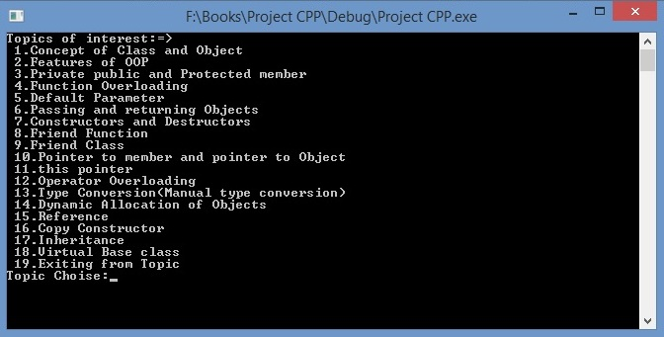

Dear Sir:

“We hope that you will like our Project.”

**C:\Users\Abdullah\Desktop\comsats_logo.jpg**